**Q1**

a.

3x0.2 + 2x0.5 + 1x0.4 – 3x0.4 + 0.3 = 0.6 + 1 + 0.4 – 1.2 + 0.3 = 1.1

b.

8m

**Q2**

a.

K: 

R: 

c: 

t: 

P: 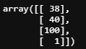

K[R|t]P: 

u = 45040 / 100 = 450.4

v = 46100 / 100 = 461

The location is (450, 461)

b.

Lab: y = (50 / 21) * x -109.095

Lcd: y = (13 / 9) * x – 75.333

Lbd: y = -1.55 * x + 284

Lac: y = -1 / 3 * x + 106

So:

v1: (36, -23)

v2: (146, 57)

**Q3**

* A point in the first image H looks the same in the second image I, for grayscale images, this is brightness constancy.
* Points do not move very far.
* There are no problems like the aperture problem or the barber pole illusion problem.
* There are textures in the image, which means there are points for tracking and comparison.

b.

According to the equation:

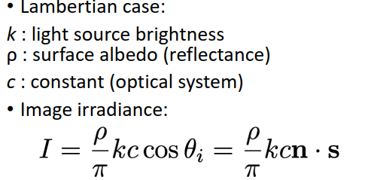

Now s is given as the light direction, so the intensity value changes according to the surface normal (n).

From the image we can know the intensity value I. We can know the surface normals because the other parameters have all given, so we can calculate the surface normals according to the equation above.

**Q4**

The coordinate system of essential matrix is the camera coordinate while that of fundamental matrix is the image coordinate (pixel).

b.

The epipolar lines are parallel, because the two cameras are set so that the images are coplanar, and the optical axes are parallel with the camera centres are lying at the same height.

**Q5**

1. Use Optical Flow to Estimating 3D structure of the house and calculate the surface normals.
2. In Shape from Shading:  
     
   where s is the light direction and n is surface normal. Now we have known n, assume we know the position of the sun in 2pm (s), the brightness of the sun (k) does not change, and from the image we know the image irradiance, so we can calculate  
    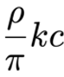.
3. With the position of the sun in 1pm donated as s’ and the result in step 2, we can calculate the new image irradiance using the equation above.

**Q6**

Assume we can measure the distance of the dots on each side in real world, and the baseline B of the two cameras.

1. For each camera, choose three visible adjacent sides on the dice as the coordinate axis.
2. Calculate the perspective projection matrix P by the measured distance of and the given coordinates of the dots.
3. Factor matrix P to inner matrix K and rotation matrix R via the QR decomposition, then calculate transformation matrix t. Now we have finished the camera calibration.
4. Same world point has same intensity (or colour) in both images, so we can match the same points by:

* For each epipolar line:
  + For each pixel in the left image:
    - Using a sliding window, compare with the pixels on same epipolar line in right image.
    - Pick pixel with minimum match cost.

1. With the information in matrix K we can know the focal length on x direction f. From the images taken by the two cameras, we can know the pixels (uL, vL) and (uR, vR) of the same overlapping point in the two images. For the overlapping pixels, calculate the depth via:

* d = uL – uR
* depth Z = f * B / d